Experiment 3.1

**Aim:** *To design a weather station by checking Air quality of an environment with the help of IoT.*

# Objectives:

* *Learn about MQ-135 sensor.*
* *Learn how to assemble.*

**Hardware:**

# *Arduino Uno R3*

# *MQ 135 AirQuality Sensor Module*

# *Male to Female Jumper Wire*

# *Software: Arduino IDE*

# Description:

***Arduino:***

*It is an open-source electronics platform. It consists ATmega328 8-bit Micro controller. It can be able to read inputs from different sensors & we can send instructions to the micro controller in the Arduino. It provides Arduino IDE to write code & connect the hardware devices like Arduino boards & sensors.*

**MQ-135:**

# *MQ-135 sensor belongs to the MQ series that are used to detect different gasses present in the air. The MQ-135 sensor is used to detect gases such as NH3,NOx, alcohol, Benzene, smoke,CO2 ,etc. steel exoskeleton houses a sensing device within the gas sensor module.*

# *Circuit Diagram:*

# 

# Code:

# *int sensorValue;*

# *int digitalValue;*

# *void setup()*

# *{*

# *Serial.begin(9600); // sets the serial port to 9600*

# *pinMode(13, OUTPUT);*

# *pinMode(2, INPUT);*

# *}*

# *void loop()*

# *{*

# *sensorValue = analogRead(0); // read analog input pin 0*

# *digitalValue = digitalRead(2);*

# *if (sensorValue > 400)*

# *{*

# *digitalWrite(13, HIGH);*

# *}*

# *else*

# *digitalWrite(13, LOW);*

# *Serial.println(sensorValue, DEC); // prints the value read*

# *Serial.println(digitalValue, DEC);*

# *delay(1000); // wait 100ms for next reading*

# *}*

# Output:

# 

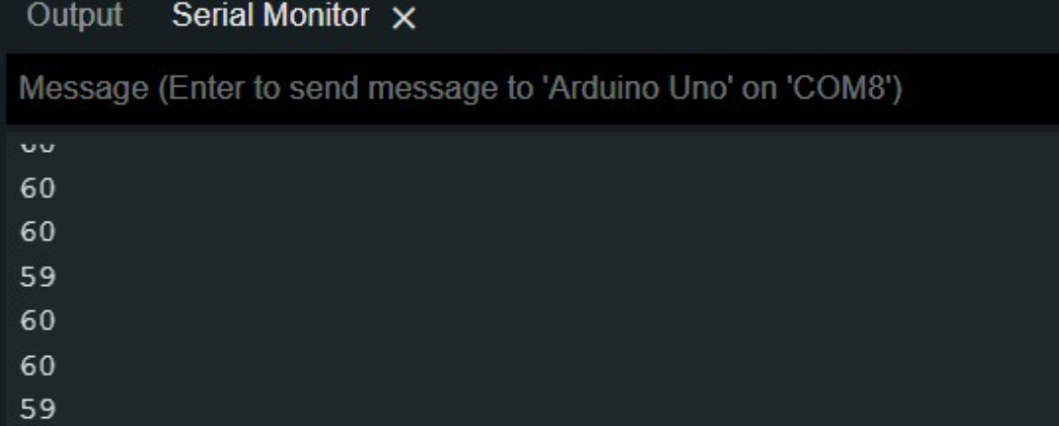

# Learning Outcomes:

1. *Learn the use of sensors.*
2. *Learn to perform task on real hardware without using any virtual platform.*
3. *Learn to know about how MQ-135 works.*